Practice Lab Manual – J2EE Configuration
Version No.: 1.0
Date: 05-Apr-2011

Copyright Notice
This document contains proprietary information of HCL Technologies Ltd. No part of this document may be reproduced, stored, copied, or transmitted in any form or by any means: electronic, mechanical, photocopy or otherwise, without the express consent of HCL Technologies. This document is intended for internal circulation only and not meant for external distribution.

Revision History
Version No | Date | Prepared by / Modified by | Significant Changes
1.0 | 05-Apr-2011 | Meena Ramasubramanian | Installation and Configuration instructions.

Glossary
Abbreviation | Description

Table Of Contents

1 Environment Setup 4
Tools Required 4
2 Install the Version Control Client 4
Checkout Project using TortoiseSVN 6
3 Install the Compiler Kit 9
4 Configure JDK 1.6 11
5 Install the Web/Application Server 14
6 Configure Tomcat Manager 17
7 Install the Database 18
8 Configure MySQL Server 5.1 19
9 Install IDE 25
10 Get Artifacts of the Project 26
Get the source code from the version control server 28
Configure the application in IDE 30
Integrate the application server and database with the IDE 33
Deploy the application using the IDE 34
Deploy the application from command line 35
11 Install the XML Parser 37
12 Setup the ANT Tool 38
13 Install Struts and Hibernate 38
14 Install and Configure JUDE-Astah tool 40

Environment Setup
This document helps you install and configure the tools required to develop a software application in Java.

Tools Required

Sl No. | Name | Version | Purpose
1 | JDK/Java SDK(J2SE) | 1.6 | To compile the source code.
2 | Tomcat | 6.0 | Web Server where the application is installed.
3 | Eclipse | 3.6 | IDE for modifying source code.
4 | MYSQL | 5.5.9 | Database server
5 | Tortoise SVN (Subversion) | 1.6.12 | Version control of the source code and artifacts.
6 | XML parser (Dom4j) | 1.6.1 | To parse the XML files.
7 | ANT tool | 1.7.1 | To compile and create a WAR file.
8 | Struts | 2.0.6 | Framework for web applications.
9 | Hibernate | 3.0 | Object Relationship (OR) mapping tool for communicating with database.
10 | JUDE-Astah tool | 6.3 | For drawing design diagrams – Sequence and Class diagrams.

Install the Version Control Client

The procedure to install the version control tool TortoiseSVN is as follows:

Step 1. Right click TortoiseSVN and select Install.
A security warning window appears with the following statement:
The publisher could not be verified. Are you sure you want to run this software?

Step 2. Ignore the warning and click Run to start installing the software.
A welcome screen appears.

Step 3. Click Next, to proceed.
A license agreement window appears.

Step 4. Read the license agreement. Select the checkbox to indicate that you accept the terms in the license agreement.

Step 5. Click Next to proceed.
A custom setup window appears as given below: 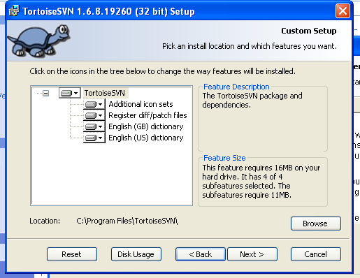

Step 6. Click Next to proceed.
A Ready to Install window appears.

Step 7. Click Install to start the installation.
The TortoiseSVN gets installed in your machine and a new window appears stating that the installation is complete.

Step 8. Click Finish to exit the setup wizard.
You have successfully installed TortoiseSVN software on your machine.

Checkout Project using TortoiseSVN
The procedure to checkout projects using TortoiseSVN is as follows:

Step 1. Select the folder to check out the project from the TortoiseSVN repository.
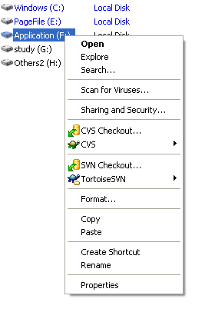
Step 2. Select TortoiseSVN and click Repo-browser.

A window appears prompting you for the URL.

Step 3. Type the URL to get connected to the SVN repository and Click OK.

The repository browser window appears.

Step 4. Select the folder to check out the project.
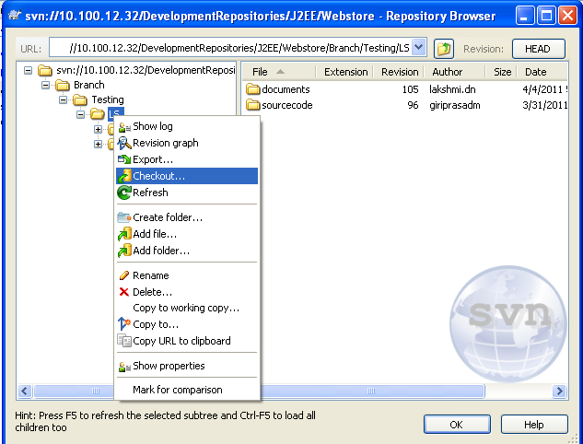

The check out window appears.
Step 5. Select the directory locator where the folder gets copied from the SVN.

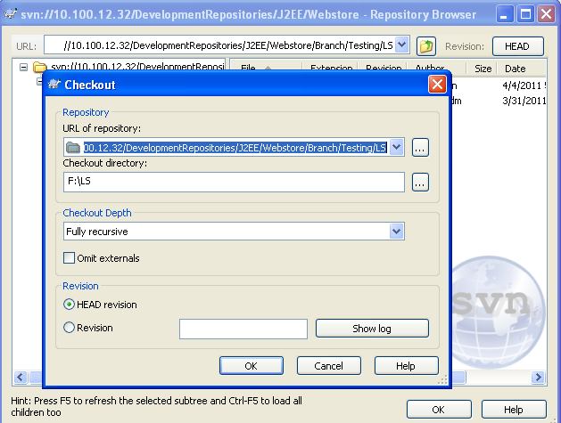

Step 6. Click OK.

Step 7. After all the files are checked out, click OK.
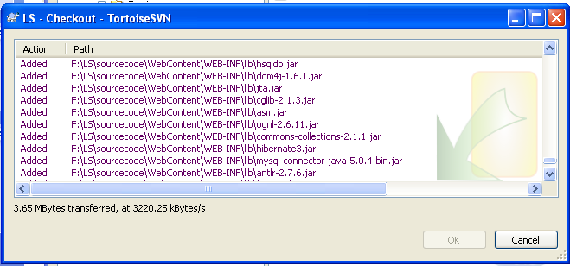
The project folder is checked out from the repository successfully.

Install the Compiler Kit
The procedure to install Java Development Kit (JDK) is as follows:
Step 1. The exe file required for installation is downloaded to your system. Double click the jdk icon (shown below).

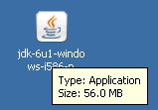
The JDK update window appears indicating that Windows is configuring the JDK update. Once the configuration is complete, the license window appears.

Step 2. Read the license agreement and click Accept.
The Custom Setup window appears.

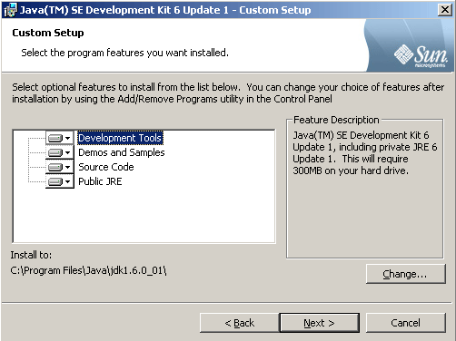
Step 3. Click Change to select the installation directory.
The default directory is C:\Program Files\ Java\jdk1.6.0_01.
Step 4. Click OK.
Installation of the JDK begins. After the installation is complete, the custom setup window for Java Runtime Environment appears.

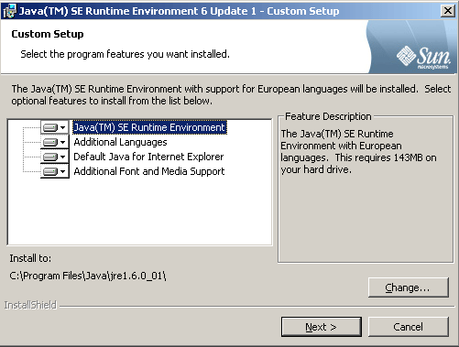

Step 5. Click Change to select the installation directory for the Runtime Environment.
The default directory where JDK is to be installed appears. Click OK to retain the default installation directory.
NOTE: Do not change the default installation directory.
Installation begins. After the installation is complete, the completion window appears.
Step 7. Click Finish to exit the installation wizard.

The above installation creates two folders jdk1.6.0_01 and jre1.6.0_01 under the
C:\ Program Files\ java folder.

Configure JDK 1.6
To use Java Compiler and Runtime Environment for compiling and running java programs, you need to set the following system environment variables:
Step 1. Right click the My Computer icon from the desktop.

Step 2. Select Properties.
The System Properties window appears.

Step 3. Click the Advanced tab.

Step 4 . Click Environment Variables.
The Environment Variables window appears.

Step 5. Select the system variables pane, select Path and click Edit.
The Edit System Variable window appears.

Step 6. Add C:\Program Files\Java\jdk1.6.0_01\bin to the existing values in the Variable Value field.

Step 7. Click OK to return to the System Variable window.
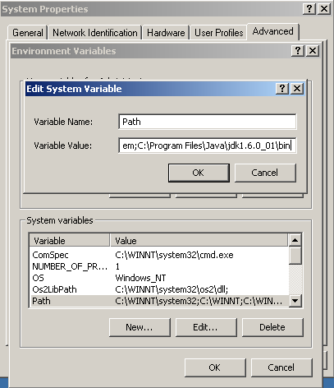

Step 8. Select JAVA_HOME variable under system variables and set the value to C:\Program Files\Java\jdk1.6.0_01 .
If this variable is not available in the system variables pane, do the following:
- Click New to create a new system variable.
- Enter the variable name as JAVA_HOME
- Enter the variable value as C:\Program Files\Java\jdk1.6.0_01 .
- Click OK.
This variable is used by other applications to find sthe JDK installation directory. For example, Tomcat server uses the JAVA_HOME variable to find the installation directory of JDK.

Step 9. Go to the command prompt, type javac and hit enter.
Successful installation of JDK gives an output as in the following screen shot:
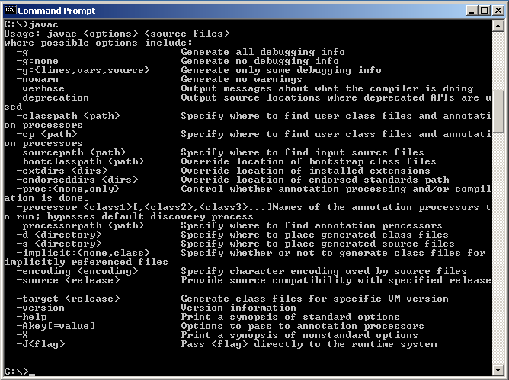

Install the Web/Application Server
The procedure to install Apache Tomcat 6.0 is as follows:
Step 1. Unzip the .zip file and double click the apache-tomcat-7.0.0.exe file.
A Welcome screen appears.

Step 2. Click Next to start the installation.
The License Agreement window appears.

Step 3. Click I Agree, after reading the licensing agreement.
Another window appears prompting for the install location

Step 4. Retain the default location and click Next.

The Tomcat basic configuration window appears. 8080 is the default port value for tomcat server to service the HTTP requests.

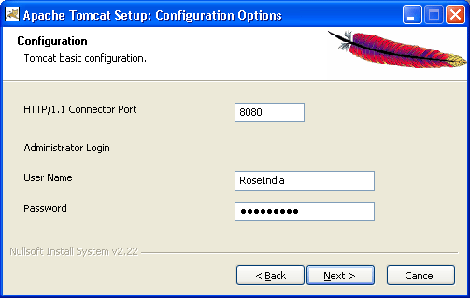

Step 5. To change the port number:
  - Open ..\Tomcat 6.0 \conf \server.xml file.
  - In the server.xml file select the Connector tag and change the port number.

Step 6. Provide a User Name and Password.

Step 7. Click Next to proceed with the installation.
The window for Java Virtual Machine path selection appears.
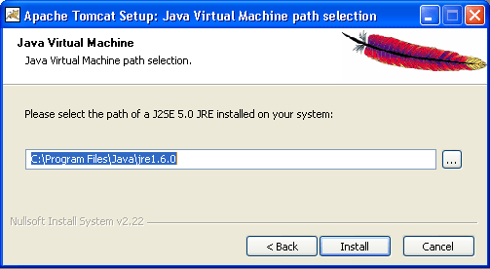

Step 8. Click the […] button to select the location of the JRE folder.

Step 9. Click Install.
Installation of Apache tomcat at the specified location begins, and a progress window appears. To get information about the installer click Show details.
The Tomcat Completion window appears and the Run Apache Tomcat option is chosen by default.

Step 10. Click Finish.
The Apache Service Manager window appears. The service manager attempts to start Apache Tomcat service. Once the service starts, an icon is displayed in the toolbar panel as given below:
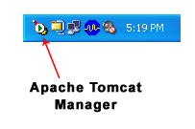

Configure Tomcat Manager
You can configure the Tomcat Manager either from the Control Panel or by clicking on the icon in the toolbar panel.
Step 1. To configure from the toolbar panel, double click the Tomcat Manager icon.
The Tomcat properties window appears.
Step 2. Click Start to start the service.
Step 3. Open a web browser and type http://localhost:8080 in the address bar, to test the Tomcat server.
Following content appears:
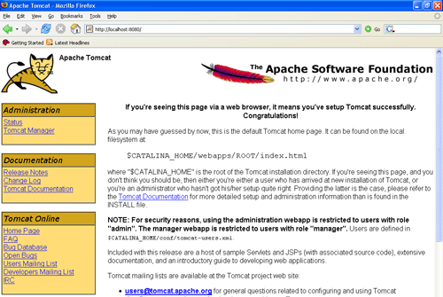

Install the Database
The procedure to install MySQL Server 5.1 is as follows:
Step 1. Double click the MSI installer to start the installation.
The welcome screen appears.
Step 2. Click Next to continue.
Step 3. From the setup options, select Typical.
Complete and Custom are the other options available.
Step 4. Click Next.
The Ready to Install window appears as follows:
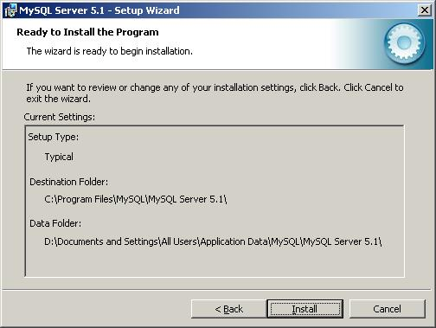

Step 5. Click Install to continue.
The progress window appears. Once the installation is complete, an information window appears giving details about MySQL Enterprise Subscription.
Step 6. Click More... to get more information.
Step 7. Click Next to continue.
The setup completion window appears.
Step 8. Check Configure the MySQL Server now checkbox to configure it after the installation is complete.
Step 9. Click Finish, to complete the installation.

Configure MySQL Server 5.1
If you selected the Configure the MySQL Server now option in the last step while installing MYSQL Server, the configuration wizard starts automatically when the installation completes.
Alternatively, you can launch the configuration wizard by clicking Start > Programs > MySQL > MySQL Server 5.1 > MySQL Server Instance Config Wizard.
The welcome screen appears.
Step 1. Click Next.
The Instance Configuration window appears.
Step 2. Select Standard Configuration, if this is the only MySQL server installed on your computer. Or else, you can select the Detailed Configuration option.
Step 3. Click Next.
You will be prompted to choose the server type.
Step 4. Since this instance of MySQL server is running on a development box, select Developer Machine as the server type.
Step 5. Click Next.
You will be prompted to select the database usage.
Step 6. Depending on the purpose of your development box, you can select either Multifunctional Database or Transactional Database Only.
Step 7. Click Next.
You will be prompted to select the InnoDB table space settings. InnoDB table type is the storage engine for a transactional database. Retain the default settings for the InnoDB table type.
Step 8. Click Next.
You will be prompted to set the database engine's concurrent connections option.
Step 9. If the MySQL server on your development machine is used for decision support such as data warehousing or data mining, select Decision Support (DSS)/OLAP.
Or else, select Online Transaction Processing (OLTP) which is the most common use of MySQL server.

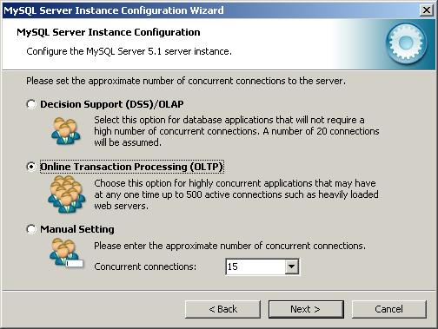

Step 10. Click Next.
You will be prompted to set the networking options.

Step 11. By default, make your selection as given in the screenshot below.
If port 3306 has been used by another instance of MySQL server, you can select port 3307 or a different port. This allows two instances of MySQL server to be accessed via different ports on the same machine.
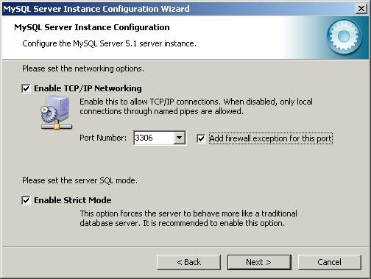

Step 12. Click Next.
You will be prompted to set the default character set.
Step 13 : Select Best Support For Multilingualism. On a development box, this gives you the flexibility to store all different sets of language characters in the database.
Step 14. Click Next.
You will be prompted to set the Windows option.
Step 15. Set the service name as MySQL51.
That clearly identifies the service as a MySQL server version 5.1 database engine, since you might install other versions of MySQL server on the same machine.
Step 16. Check the Include Bin Directory in Windows PATH checkbox, if you want to operate MySQL from the command line.
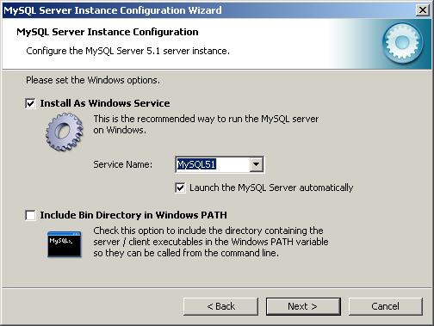

Step 17. Click Next.
You will be prompted to set a new password for the root account.
Step 18. Enter the same password in all the three text boxes as given below.
NOTE: Do not check the Create An Anonymous Account checkbox, since this leads to an insecure system.
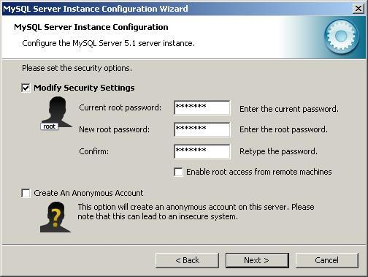

Step 19. Click Next.
The Ready to execute window appears.
Step 20. Click Execute.
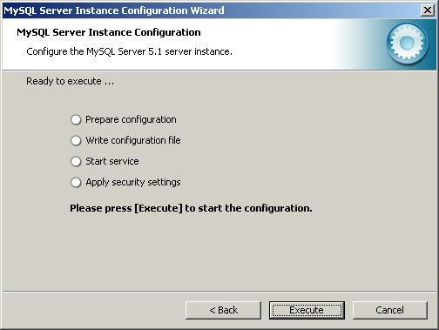
The Configuration completes successfully and the configuration file is created.
Step 21. Click Finish to close the wizard.
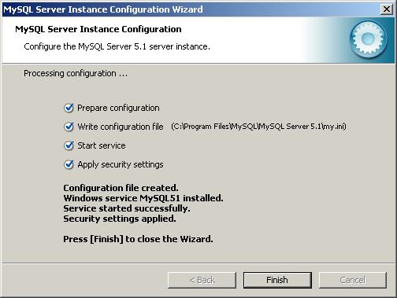

Install IDE
The procedure to install the Integration Development Environment(IDE), Eclipse Helios is as follows:
Step 1. Right click the file that you downloaded (eclipse-jee-helios-win32.zip) to unzip it.
Step 2. Select WinZip and click Extract to here.
Unzipping the file creates a folder named eclipse. You can leave the folder as such or move it anywhere else under the C:\Program Files\ directory.
Step 3. Create a shortcut on your desktop to the eclipse.exe file in the eclipse folder, by dragging it to the desktop.
Step 4. Double-click the shortcut to eclipse, from the desktop.
The Workspace Launcher window appears. Path for the workspace should be C:\Documents and Settings\username\workspace (where username is your login on the machine). You can also type a new location or browse to another location for the workspace file to be created.

Get Artifacts of the Project

The procedure to get the artifacts of the project from the version control is as follows:
Step 1. Start Eclipse.
Step 2. Add the Subclipse plug-in as follows:
- Extract the folders of Subclipse, from the downloaded file.
- Inside the extracted folder, three files named features, plugins and site.xml are available. Copy those files and paste them in the corresponding folders in eclipse folder.
- Restart Eclipse to integrate Subclipse with it.
Step 3. Click Windows > Open Perspective > Other to open the Open Perspective view.

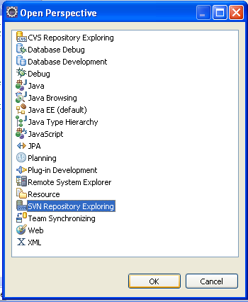
Step 4. From the open perspective window, select SVN Repository Exploring and click OK.
A new view opens for SVN Repository.
Step 5. Right click on the view, select New > Repository Location.
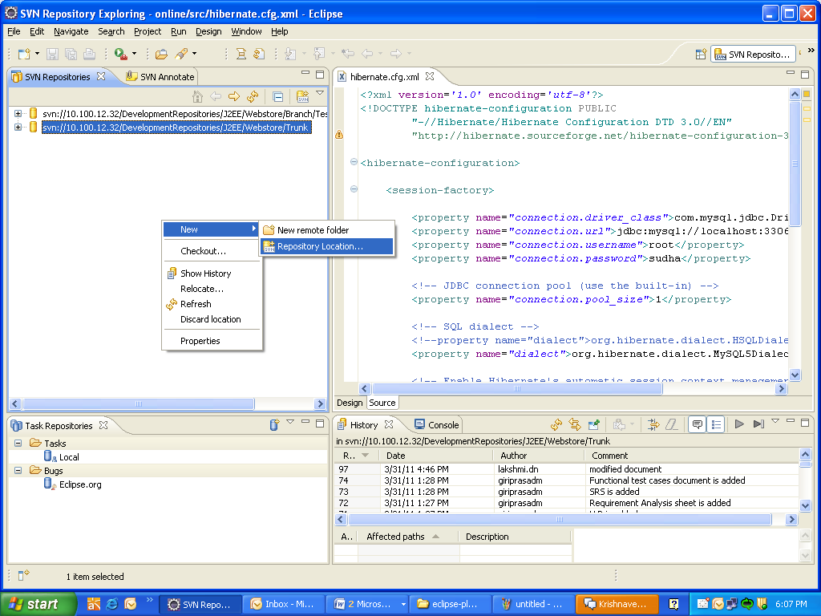

Step 6. Enter the following URLs:
- Branch for Testing—Whole Project without any bugs:
svn://*.*.*.*/DevelopmentRepositories/J2EE/Webstore/Branch/Testing
- Branch for Bug fixing and Enhancements—Project with bugs to be fixed:
svn:// *.*.*.*/DevelopmentRepositories/J2EE/Webstore/Trunk

*.*.*.* should be replaced by the actual IP address of the server where SVN repository is located.

Step 7. Enter the URL given in Step 6 based on whether you are in testing phase or in bug fixing phase, and get connected with repository.

Step 8. Click Finish.
New Repository location is created and the source code is available there.

Get the source code from the version control server

Step 9. Change the perspective to Java EE.

Step 10. Select File > New > Other.
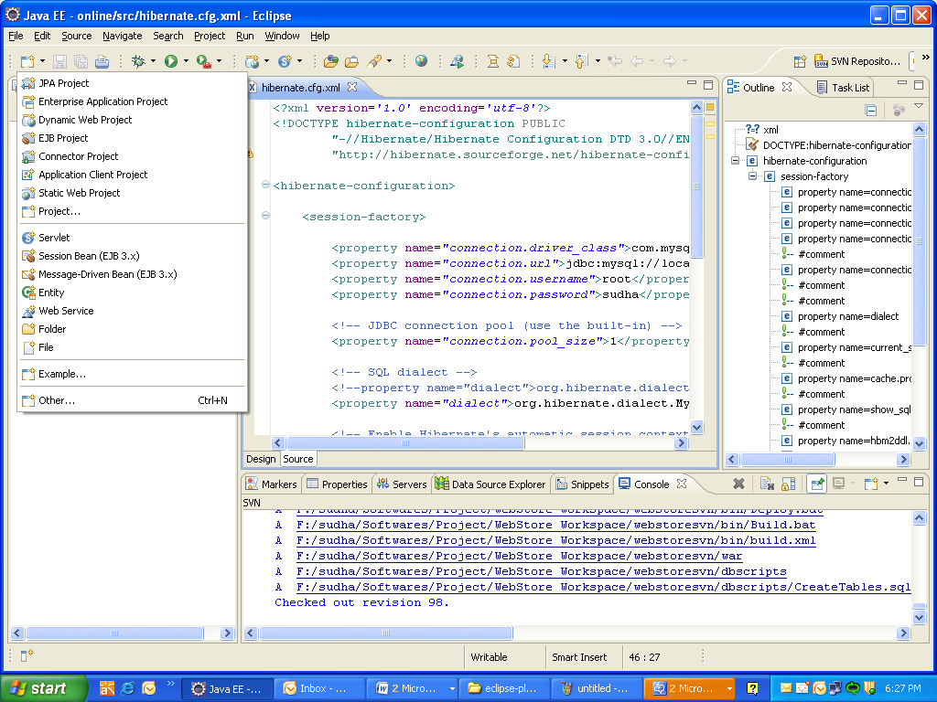

Step 11. Click on the SVN option and select Checkout Projects from SVN.
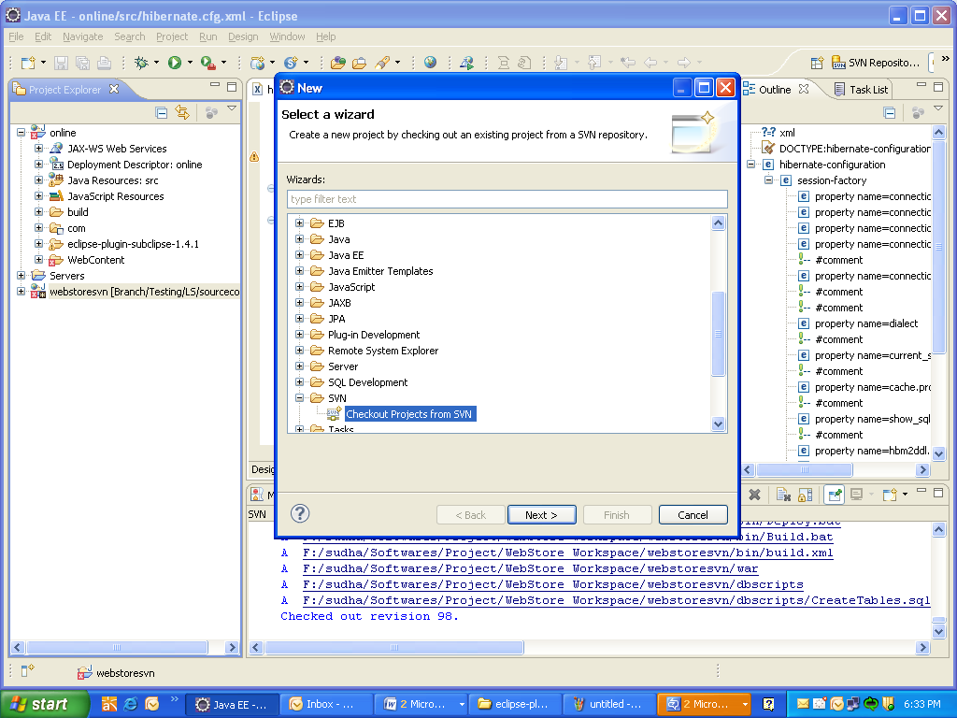

Step 12. Select the URL to download the source code from the version control server to the workspace.
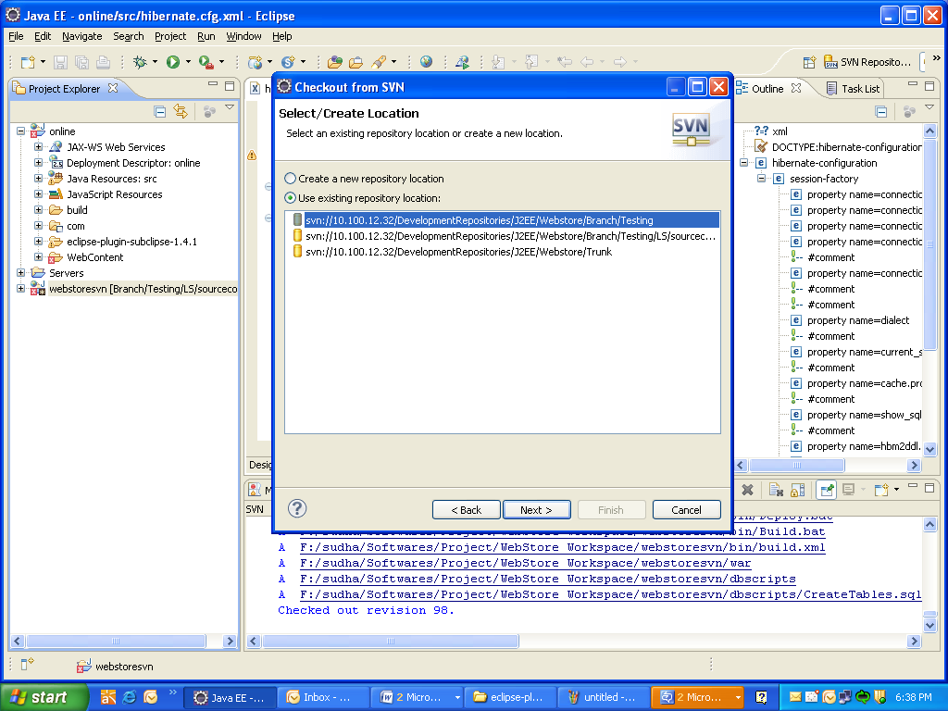

Step 13. Select the folder that needs to be checked-out from SVN and click Finish.
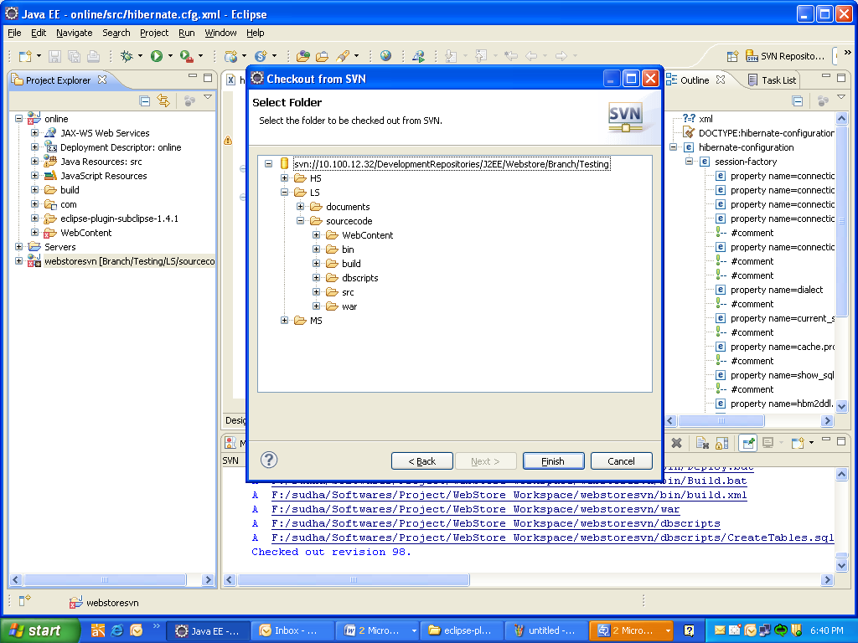

A new window appears so that you can create a new project by copying the project from the SVN repository.

Configure the application in IDE

Step 14. Select Dynamic web project.
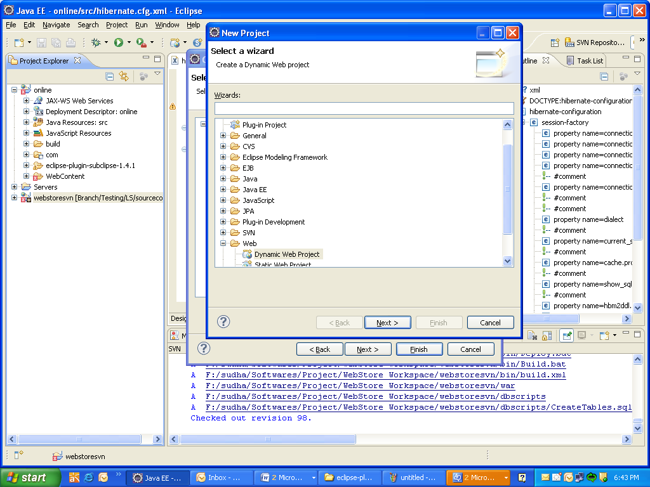

Step 15. Give the Project name and click Next.
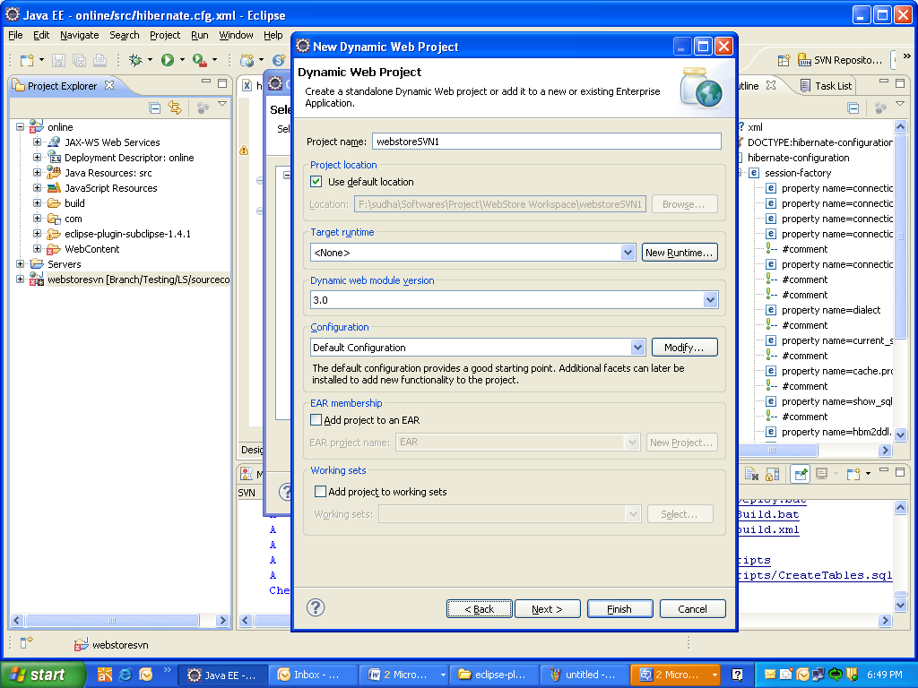

Step 16. Select Src and click Next.
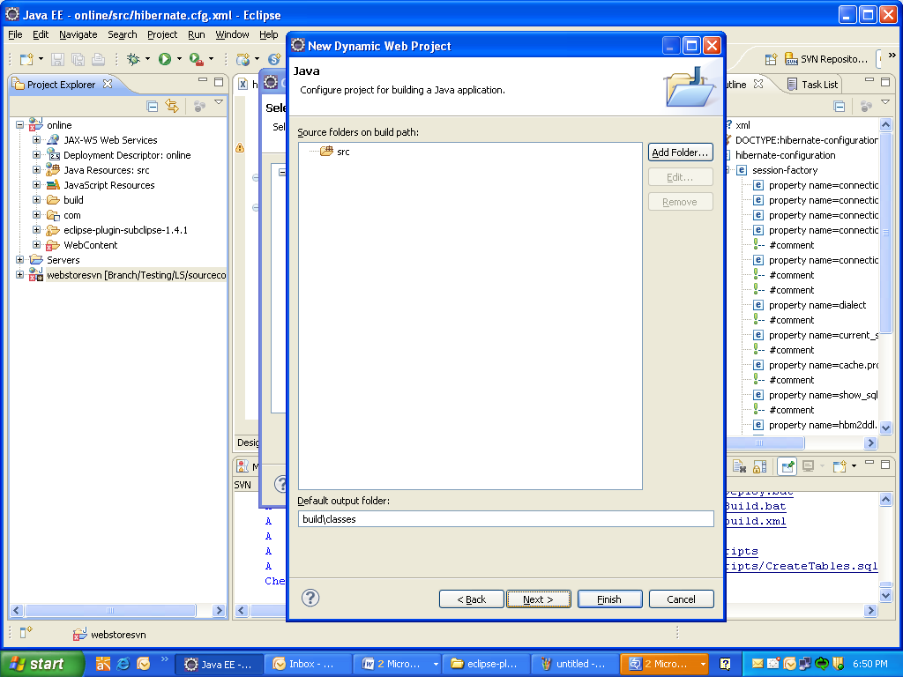

Step 17. Click Finish.
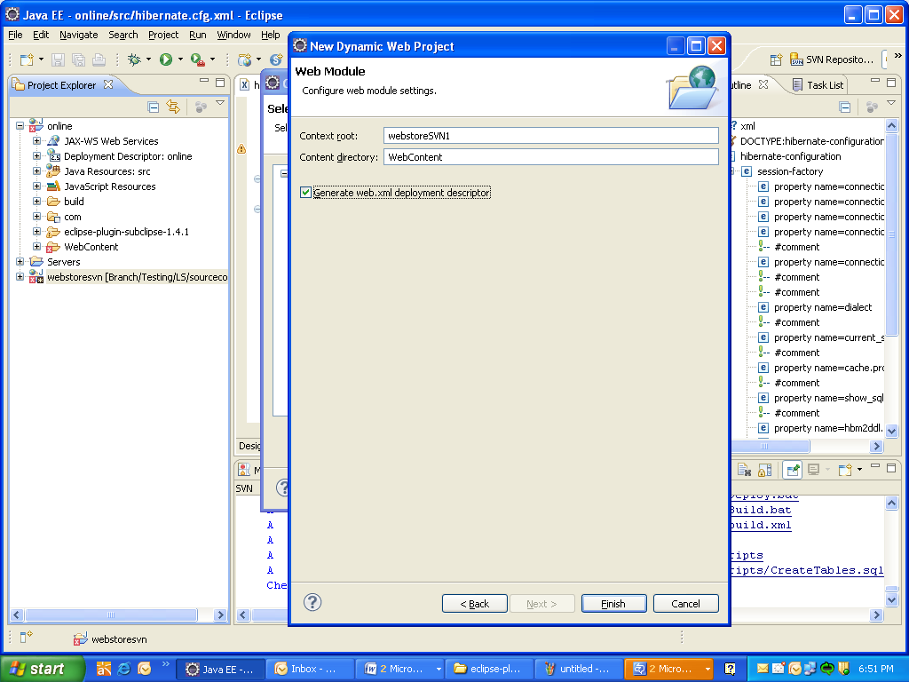
A progress window appears showing the status of the SVN checkout. A new project is created.
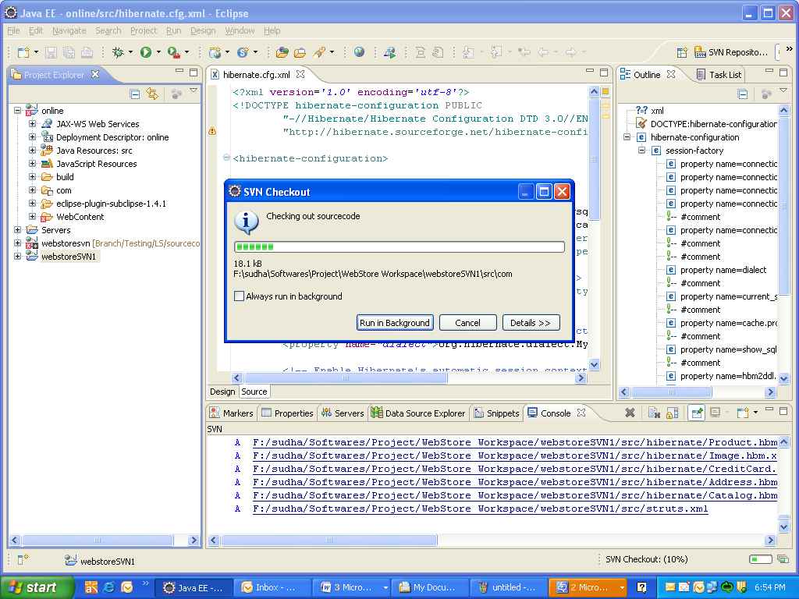

Step 18. Open the hibernate.cfg.xml file. If there is any MySQL password other than root, change it back to root.

Integrate the application server and database with the IDE
Step 19. Modify the database name as follows:
<property name="connection.url">jdbc:mysql://localhost:3306/test</property>

Deploy the application using the IDE

Step 20. After importing the necessary files, right click on the name of the project, and select Run as-Run as Server.

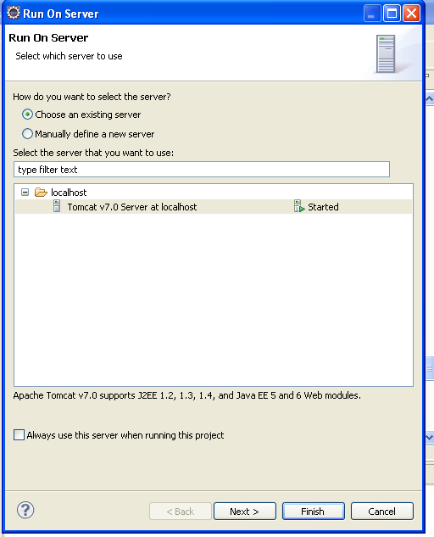

Step 21. Click Finish.
The required sign-in page is displayed as given below. 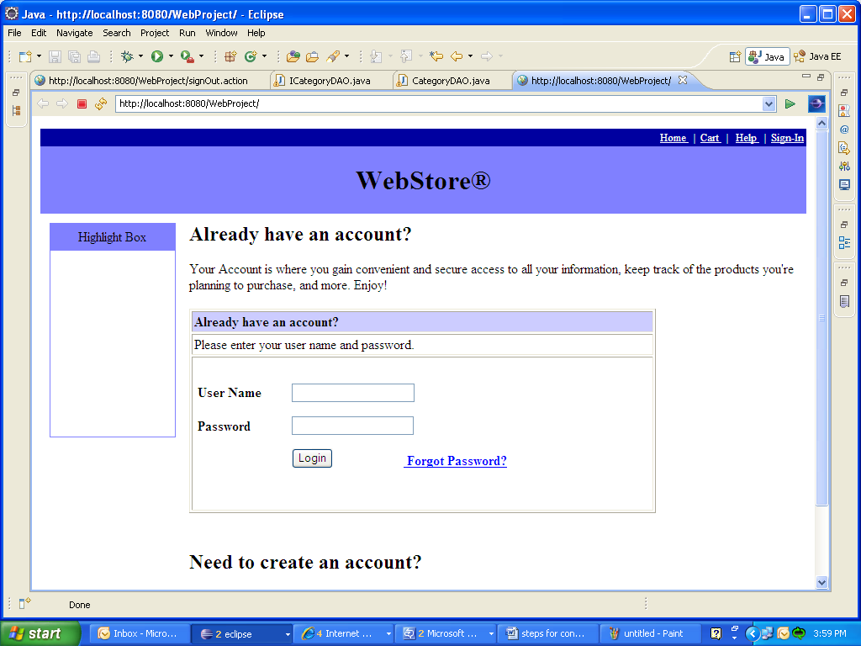

Deploy the application from command line

Step 1. From the project folder, open the bin folder that contains Buil.xml, Build.bat, and Deploy.bat.

Step 2. Modify the local machine classpath for ApacheAnt, Tomcat and Java_Home. The server classpath information is available in the files mentioned in step 1.

Step 3. Open the command prompt and type build war.
The files are compiled.

Step 4: In the command prompt, type deploy.bat.
This copies the files into the project folder.
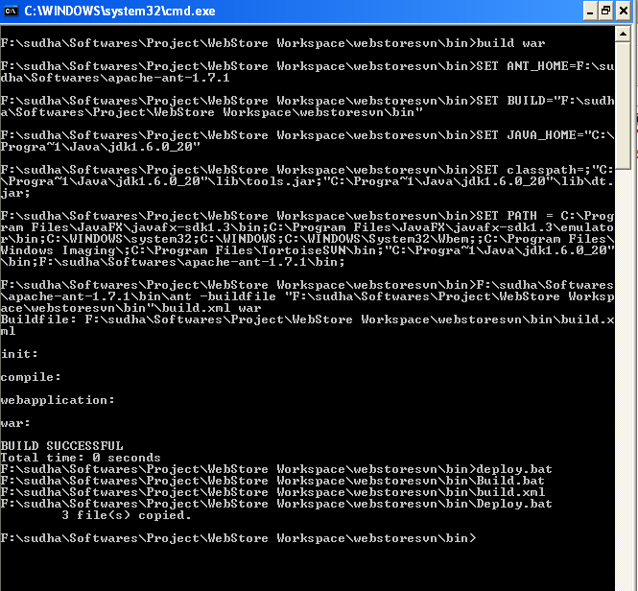

Step 5. Start Tomcat and execute the project in the browser by giving:
http://localhost:8080//WebStore/jsp/Header.jsp

Install the XML Parser
Step 1. Run eclipse and locate the workspace directory.

Step 2. Click File > New > Java Project and create a new Java Project, MyXMLReader.

Step 3. Right click your project and select Build Path > Add External Archives.

Step 4. Locate and add the dom4j**. jar archive listed under the Referenced Libraries.

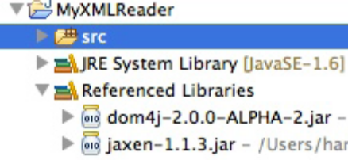

Setup the ANT Tool
Step 1. Download the Apache Ant tool.

Step 2. Run the web application manually in the command line.

Step 3. Create the path as SET ANT_HOME=F:\Softwares\apache-ant-1.7.1.

Apache Ant Setup is completed successfully.

Install Struts and Hibernate

Step 1. Expand the project structure by clicking on the project name in the project explorer.

Step 2. Add hibernate3.jar and struts2-core-2.0.6.jar under Webcontent > WEB-INF > lib.

Step 3. Under src, add hibernate.cfg.xml , struts.xml and other source related hibernate and struts action classeses.

Step 4. In web.xml, map the struts filters and the welcome pages if any.
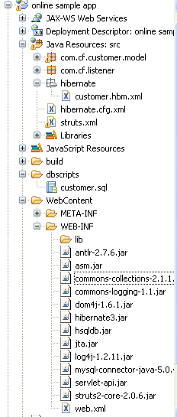

Step 5. Access the customer module http://localhost:8080/Struts2Example/listCustomerAction.action
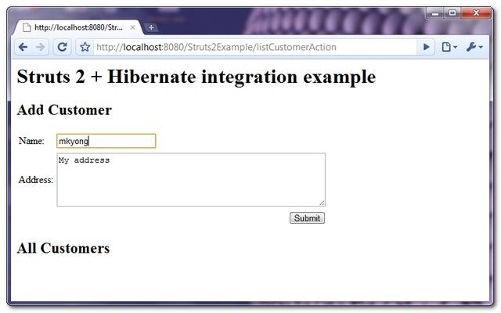
Step 6. Fill in the Name and Address fields and click Submit.

The newly added customer details are listed in the screen immediately.

Install and Configure JUDE-Astah tool
Step 1. Double click the .exe file in Jude.

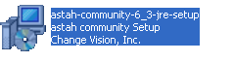
A new window appears prompting you to select the language.

Step 2. Select the language for installation and click OK.

The welcome screen appears.

Step 3. Click Next.
The license agreement screen appears.

Step 4. Select I accept the agreement, after reading the agreement.

Step 5. Select the install location and click Next.

Step 6. Select the start menu folder and click Next.

Step 7. Select Additional Tasks as follows:

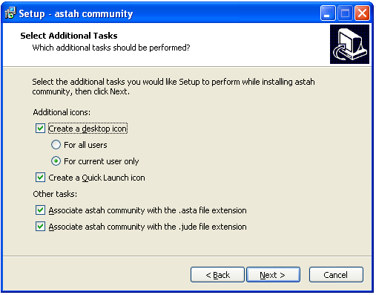

The ready to install screen appears, listing all the settings.

Step 8. Click Install.

A status bar appears showing the progress of installation. Once the installation is complete, completion screen appears.

Step 10. Click Finish.

Astah Community is launched.

